U3A Attendance System User Guide

Contents

1. Getting Started 2

2. Creating Course Instance 2

3. Create Session 5

4. Attendance 7

# Getting Started

After launching the application you will be presented with home page (Course Descriptions)

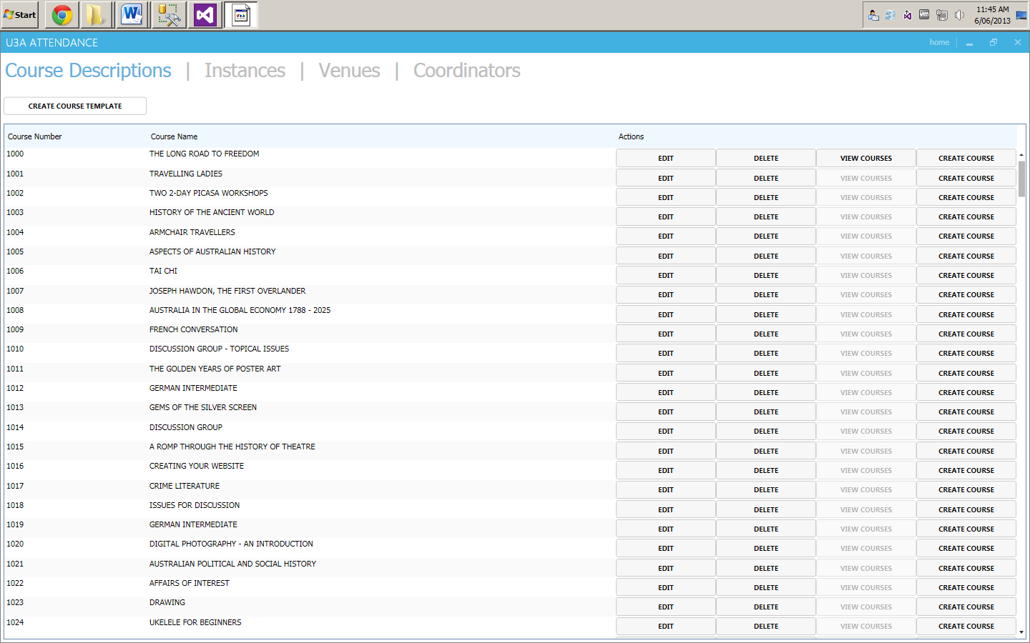

Figure 1 - Home Page

# Creating Course Instance

To create a course instance, you have to choose from a list of available course templates and press “Create Course” button



Figure 2 - Create Course Instance 1

After completing steps above, you will be presented with the Course Instance creation screen.

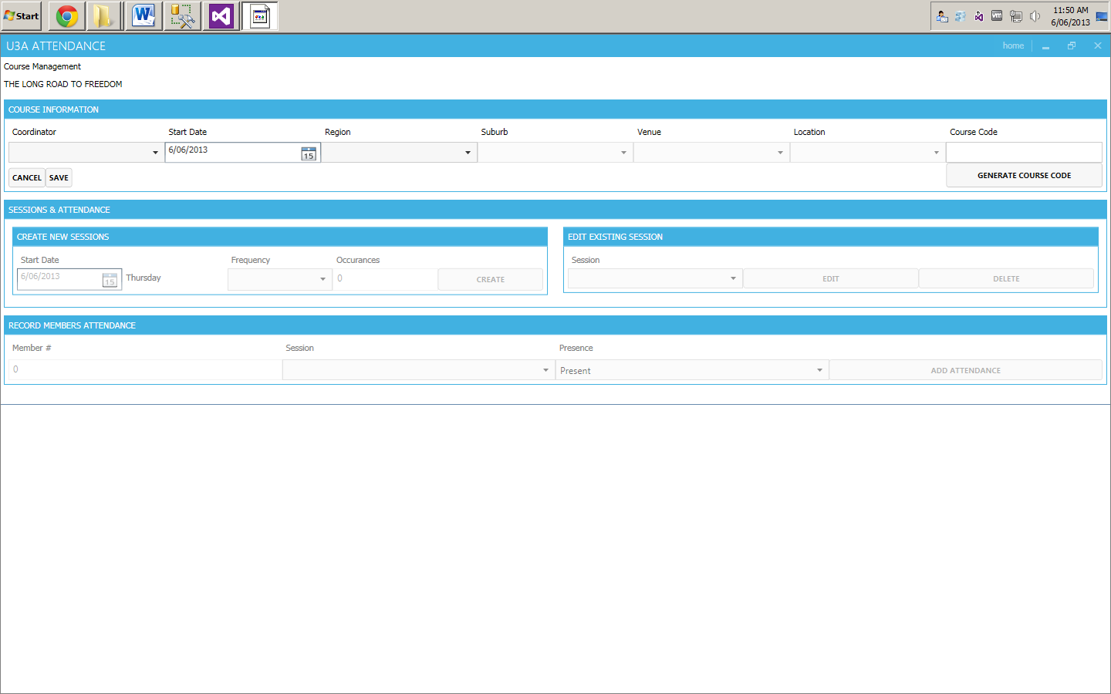

Figure 3 - Create Course Instance 2

It is required that you choose a Coordinator, Start Date, Region, Suburb, Venue and Location from the course.



Figure 4 - Create Course Instance 3

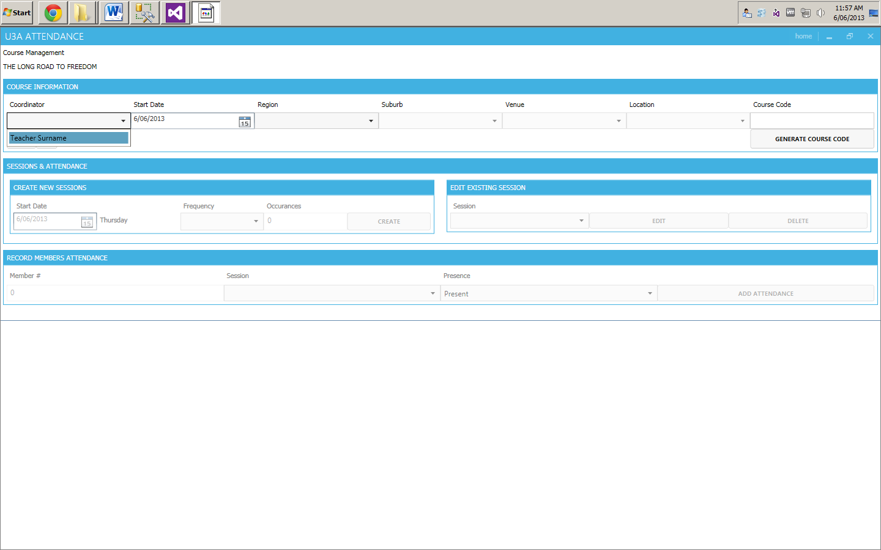 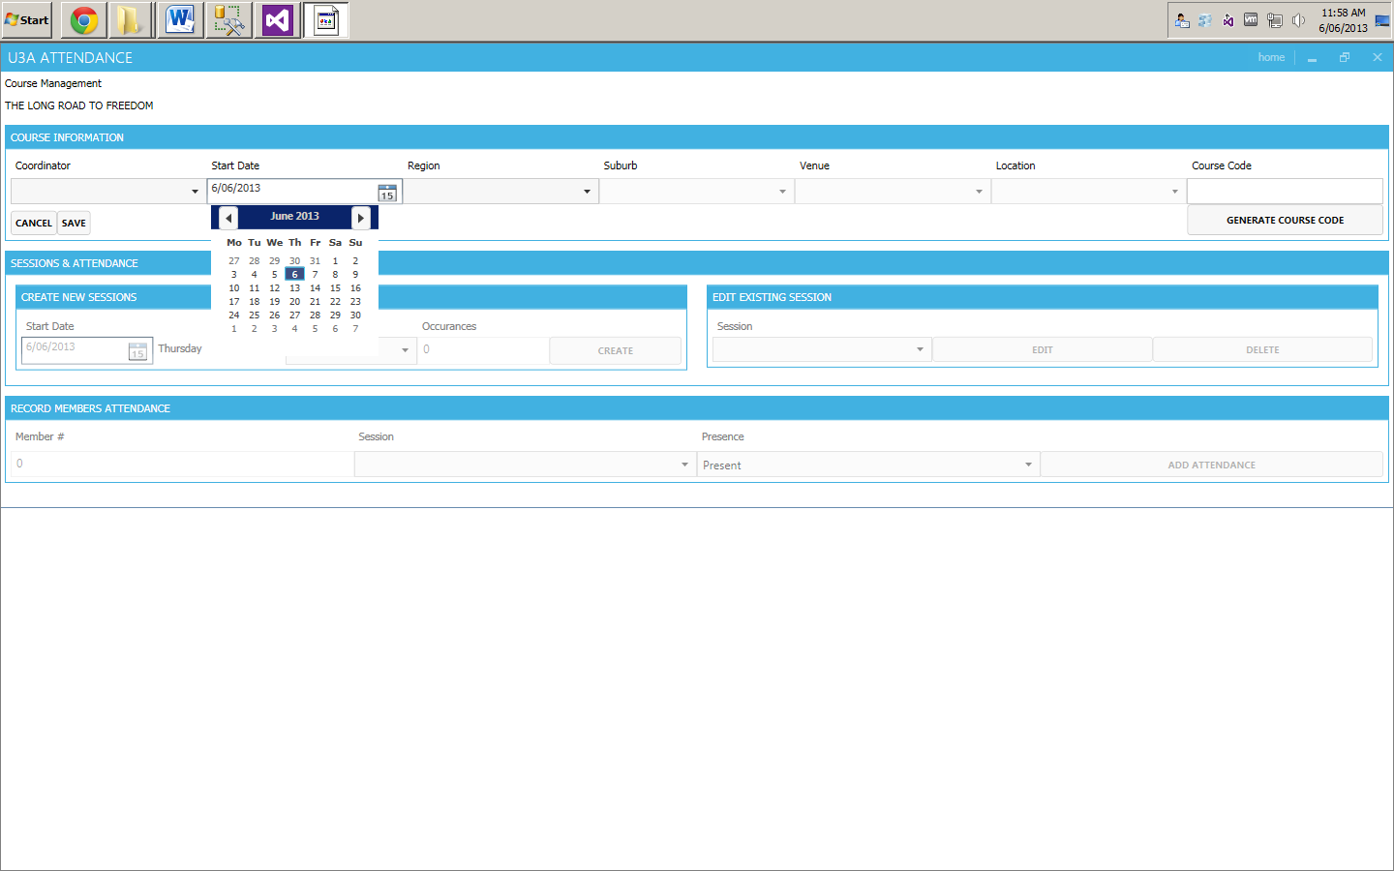

Choose Coordinator

Start Date field provides calendar view

Figure 5 - Coordinator Figure 6 - Start Date

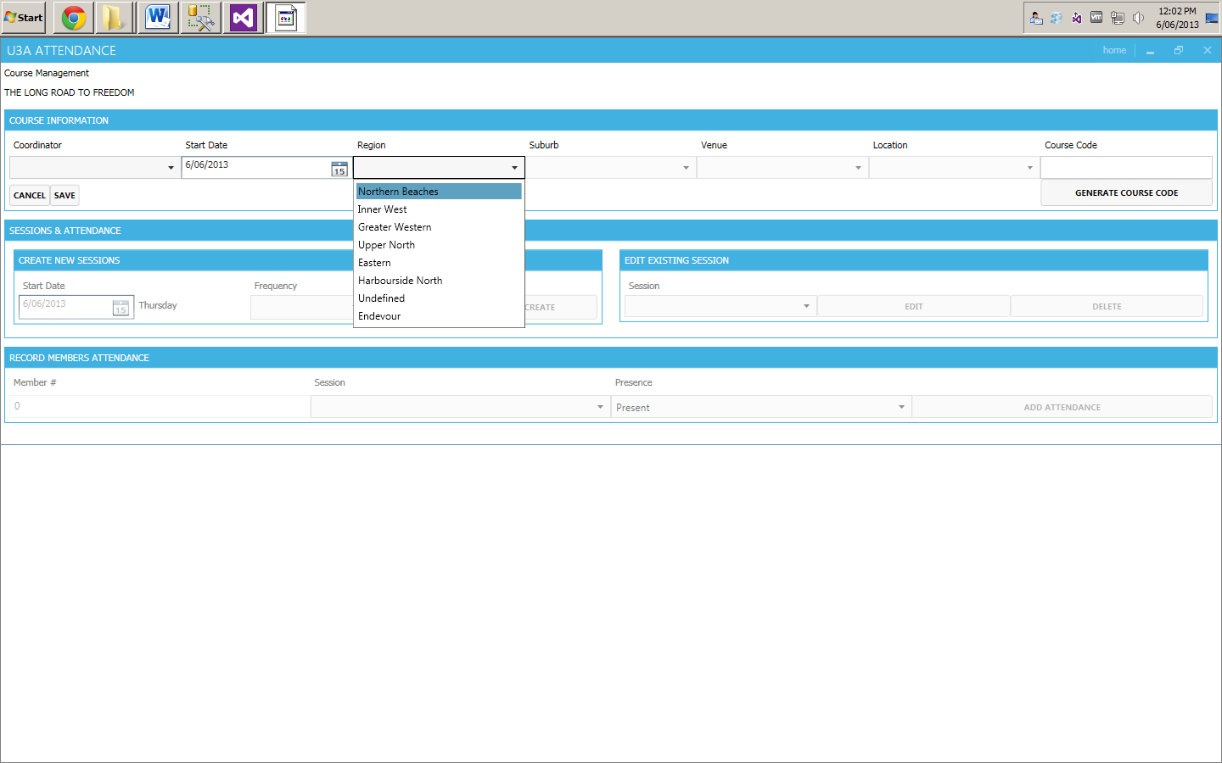 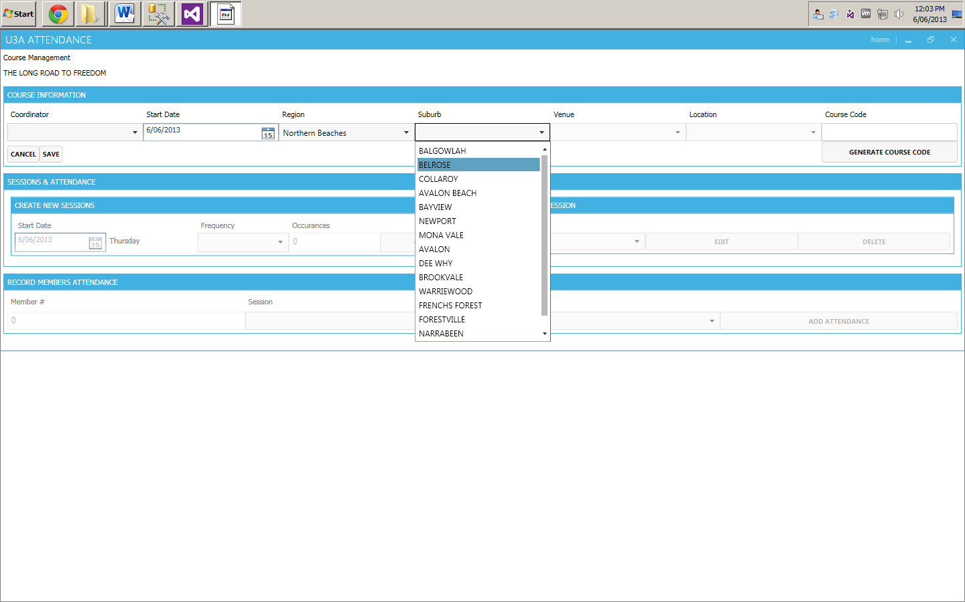

Choose a Region

By selecting a Region, only corresponding Suburbs will be displayed.

Figure 7 – Region Figure 8 - Suburb

Choose from corresponding list of venues for chosen suburb.

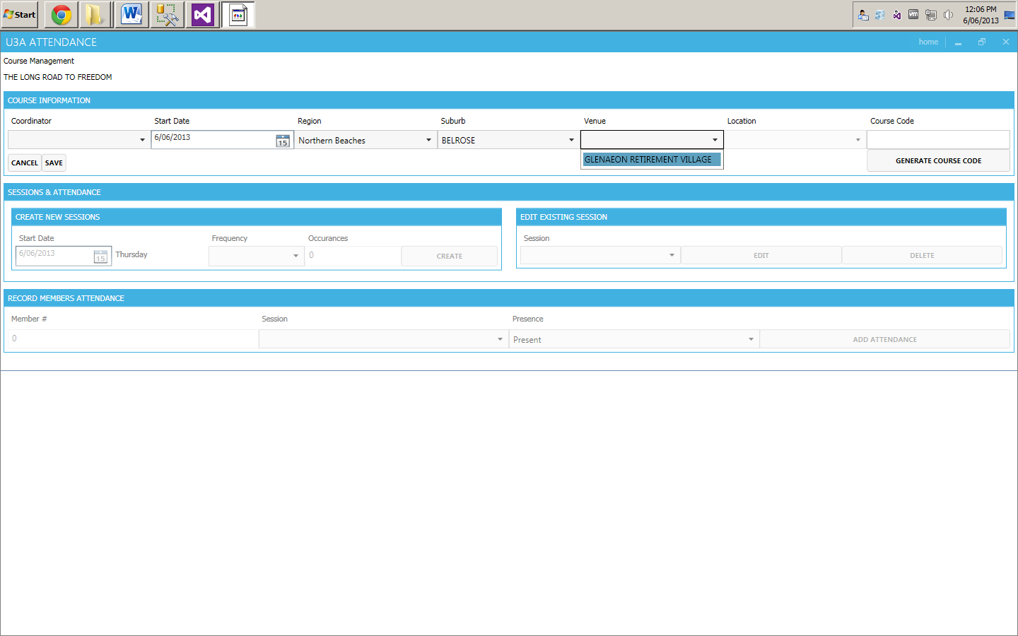

Figure 9 - Venue

Choose from corresponding list of locations for a chosen venue.

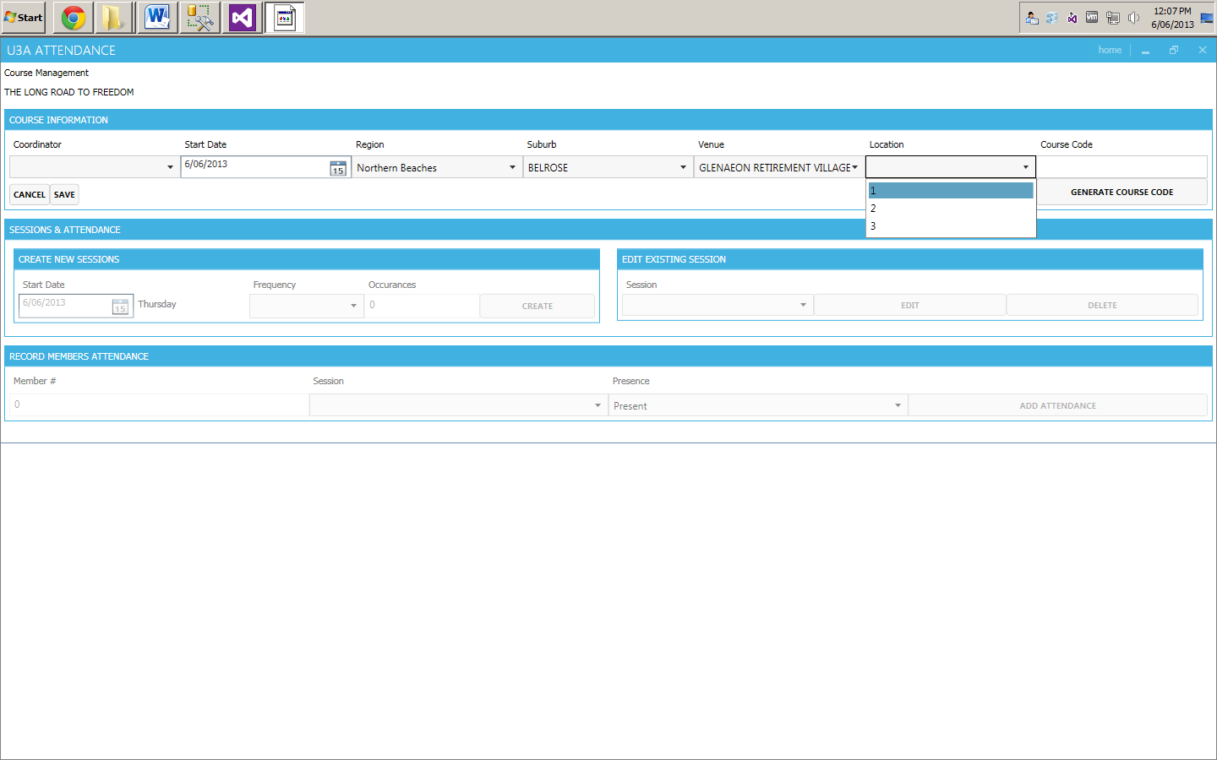

Figure 10 - Location

Every Course requires a course code. Our application gives the user a function to generate the course code relying on supplied and existing information. Note: this action can be done only after the user has chosen Start Date, Region, Suburb, Venue and Location.



Figure 11 - Generate Course Code

After completing all of the steps above you can save the Course Instance

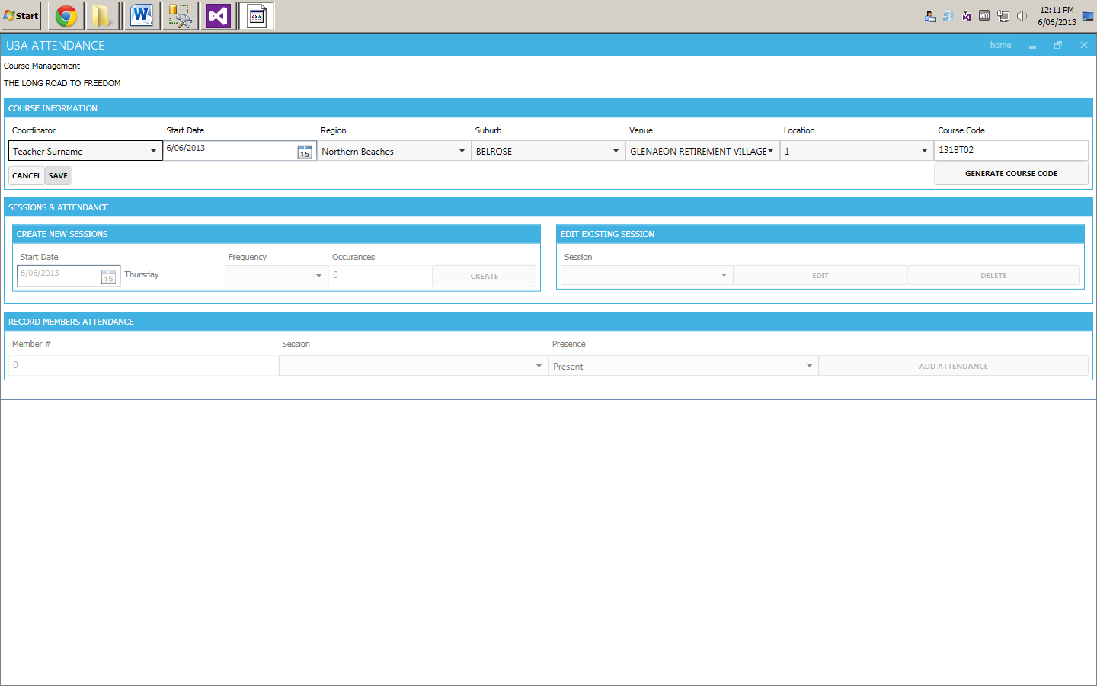

Figure 12 - Save

# Create Session

Our application gives the user an option of creating a session (or number of sessions) for a course instance straight after its creation. At first the Session and Attendance section is disabled see Figure 2. After saving the Course Instance the section becomes available.

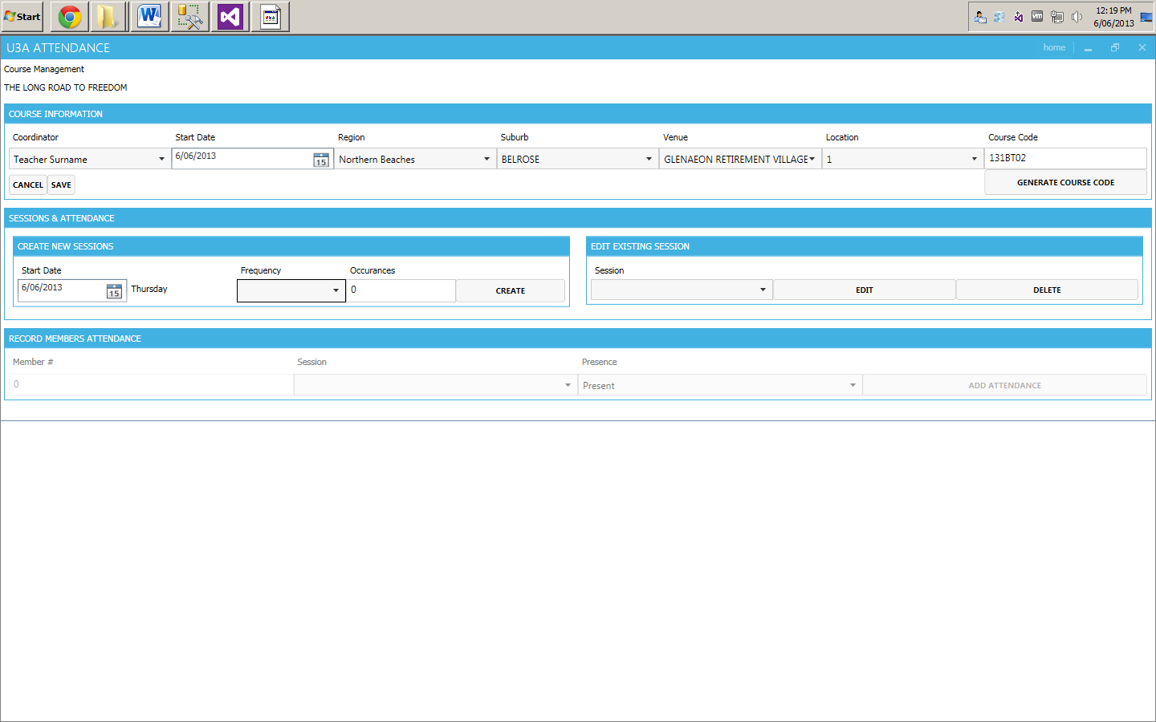

Figure 13 - Create Session

You will have to choose a Start Date the for the session

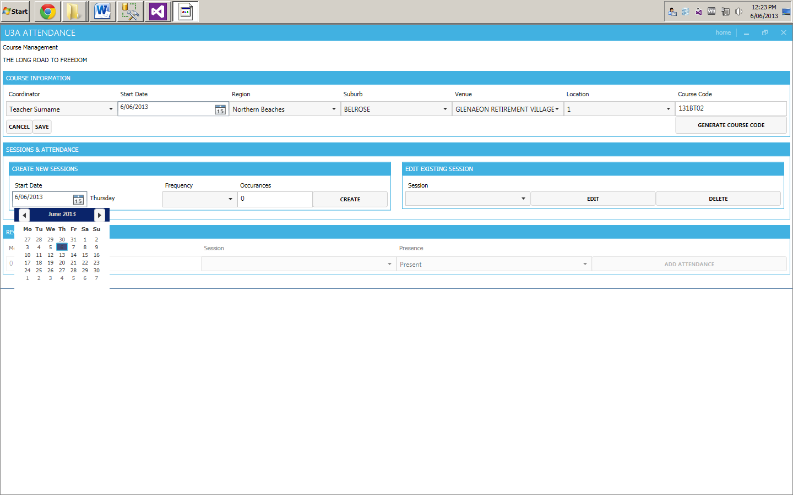 

It is possible to create a single session just by choosing Create option.

Figure 14 - Session Date Figure 15 - Create a Single Session

It is also possible to choose a frequency for the session with a number of occurrences

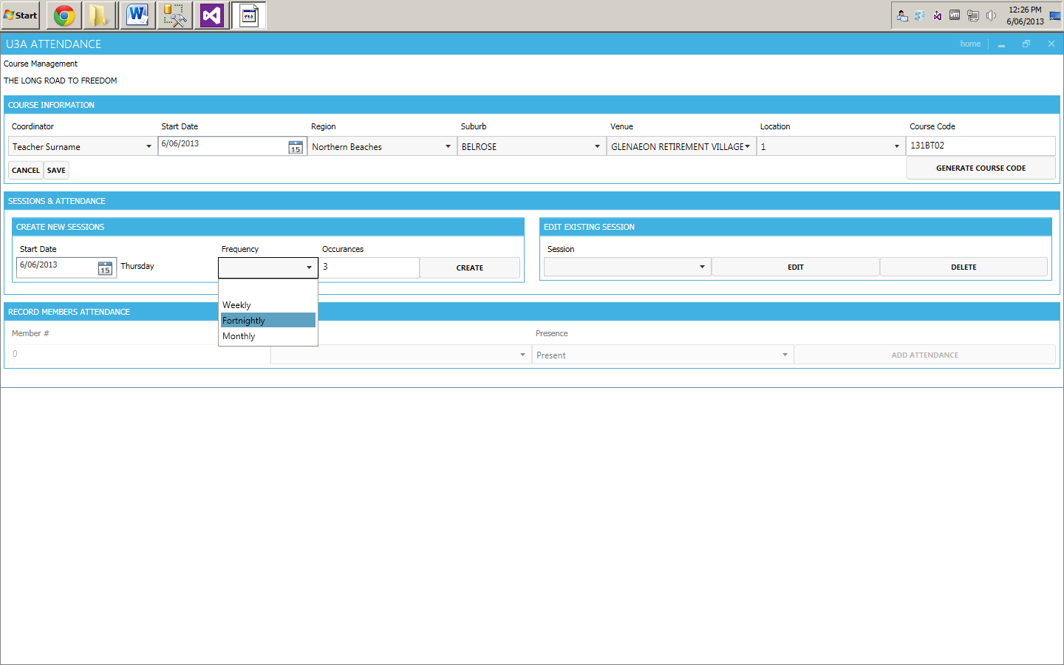

Figure 16 - Session Frequency

Creating new Session(s) enables the Session Edit section. In this case 3 weekly sessions were created as you can see in drop down list below. If you wish to edit a session, choose one and press Edit.

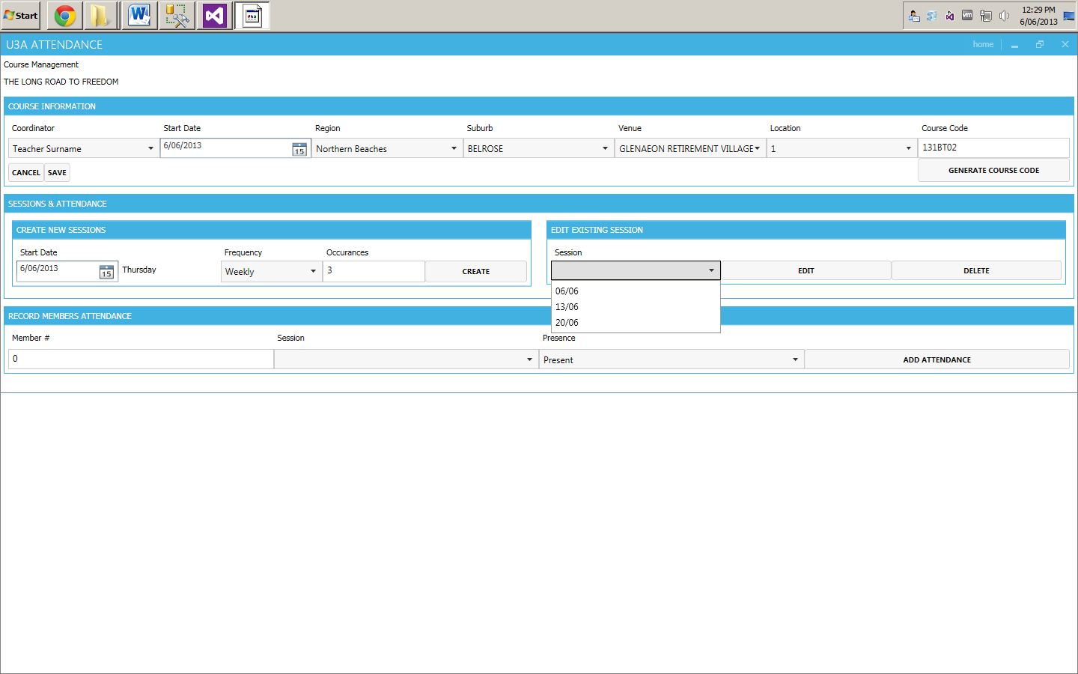

Figure 17 - Edit Session

A new pop-up will appear in which you are able to edit the date, venue and location for the session. After making any changes press save.

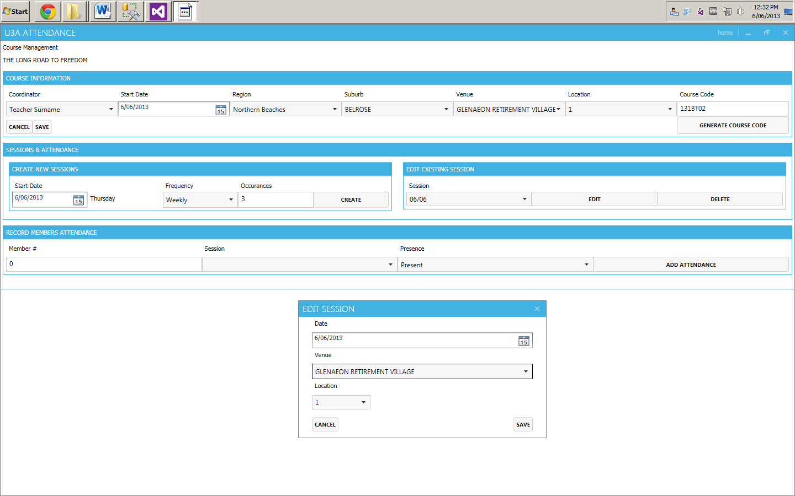

Figure 18 - Edit Session Pop-up

# Attendance

After creating Course Instance session(s), the Attendance section now becomes available.

To create an attendance record you will have to enter a valid Member number, Session Date and Presence.

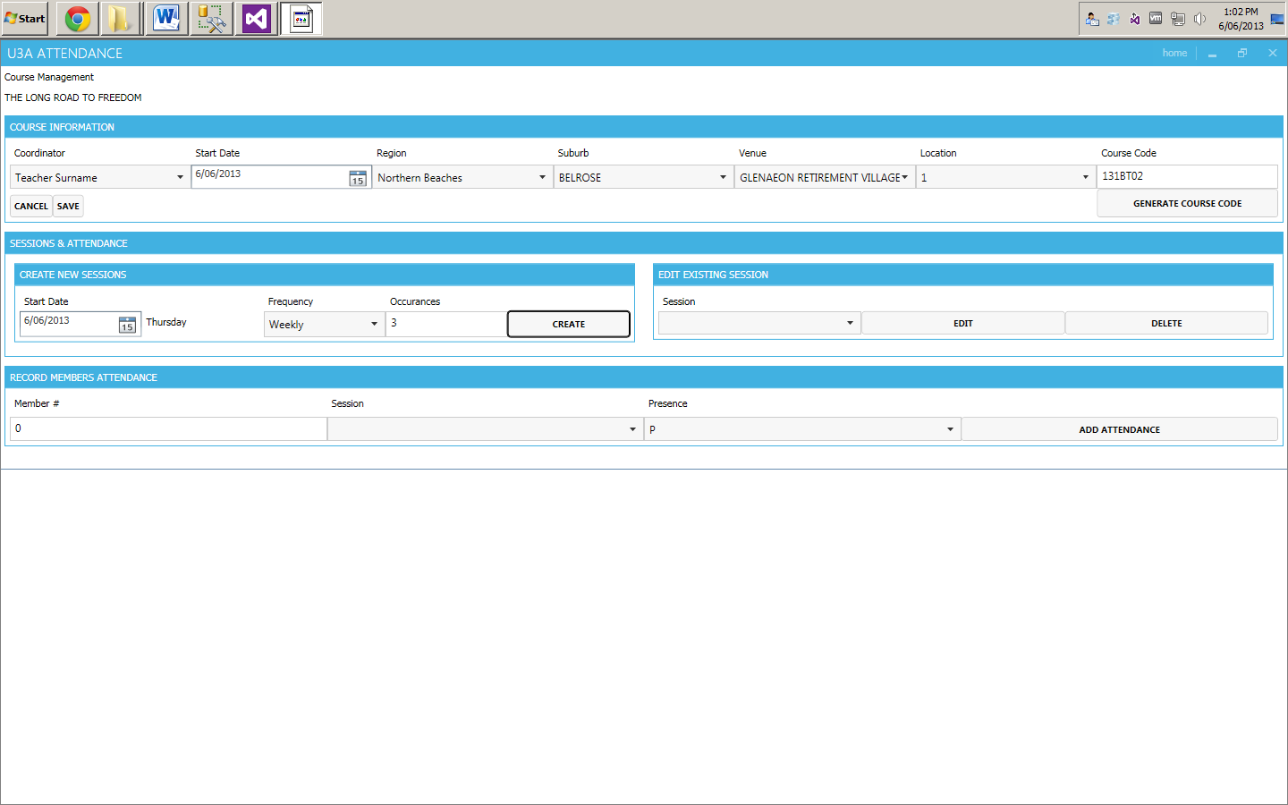

Figure 19 - Create Attendance 1

Enter information in designated fields and choose Add Attendance

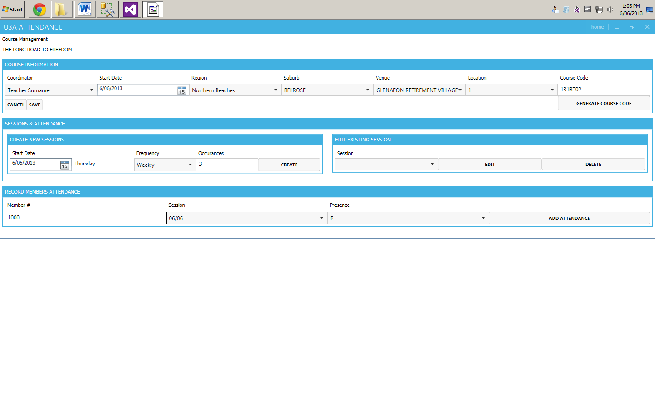

Figure 20 - Create Attendance 2

Application will generate an attendance grid based on entered information. The attendance will be recorded only for the session date that was chosen during creation.

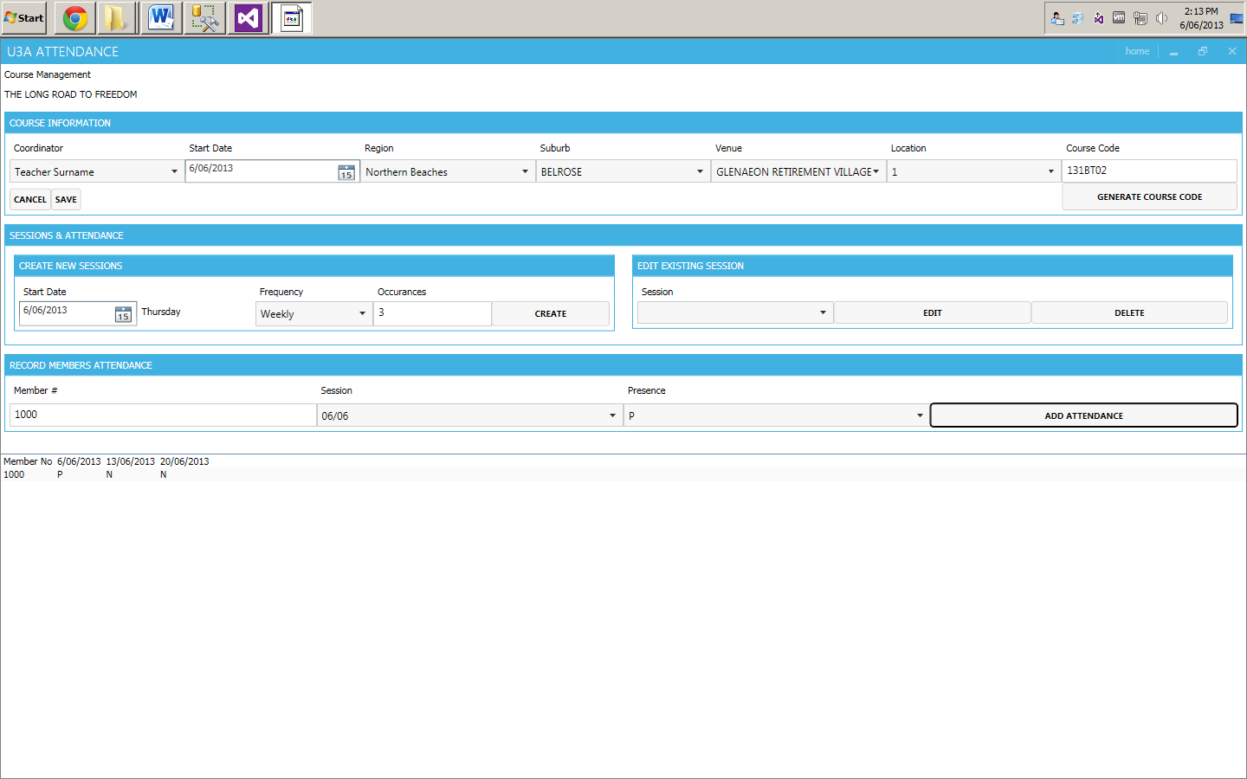

Figure 21 - Attendance Grid 1

To change a presence for another session current one, you will have to choose first a session date and the select a presence identifier.

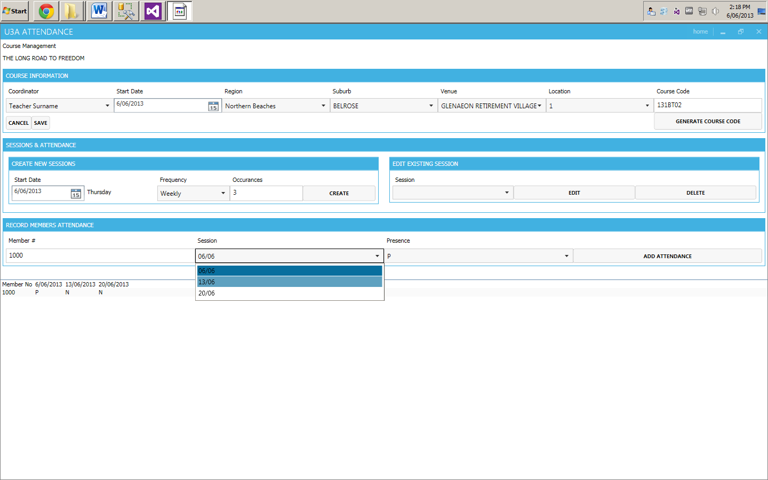

Figure 22 - Edit Attendance 1

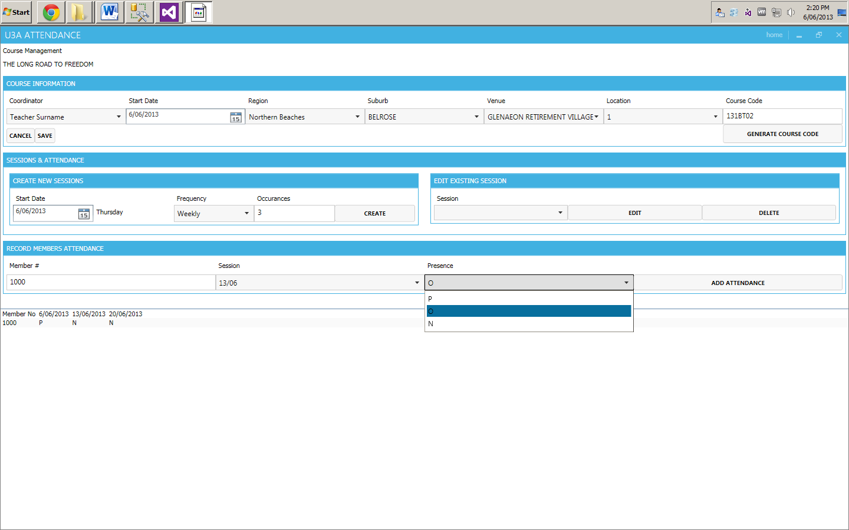

Figure 23 - Edit Attendance 2

After performing steps above you will notice Presence change in the Attendance grid.

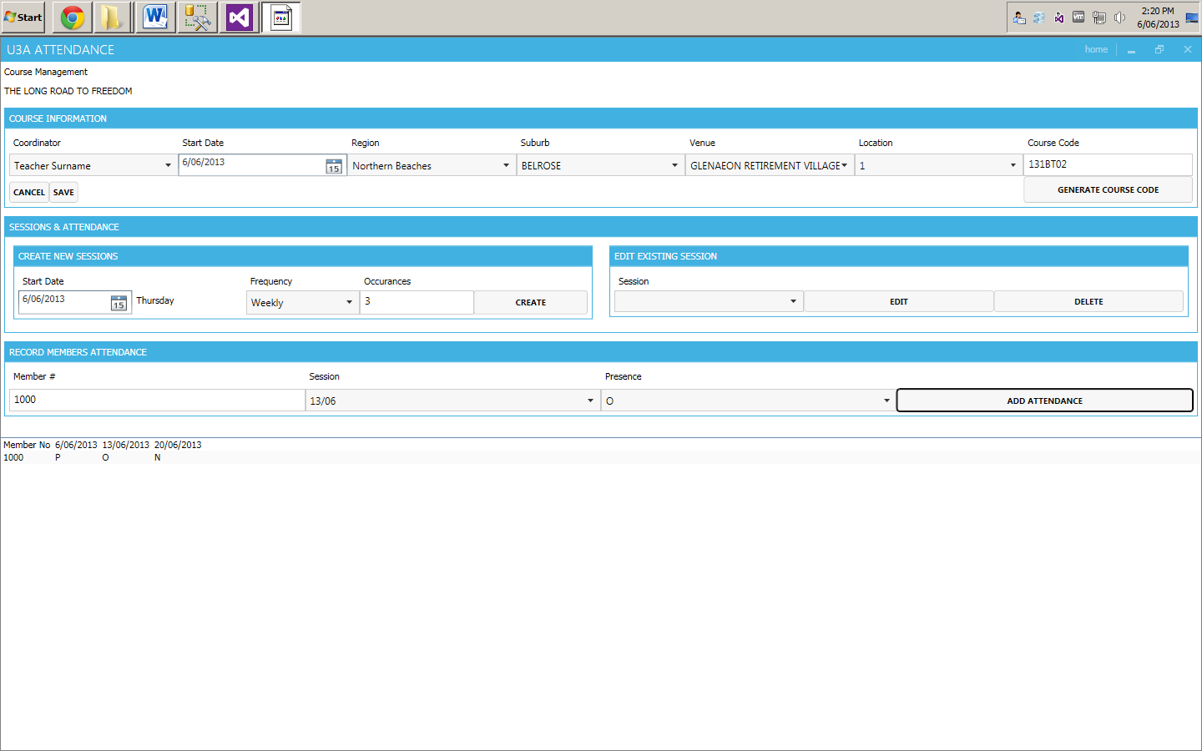

Figure 24 - Attendance Grid 2